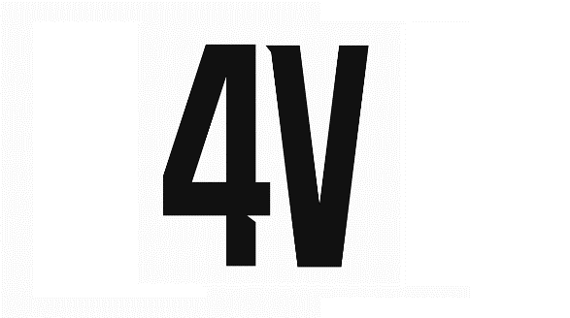https://4voices.studio/main-2/

+7926 1038778 (WhatsApp, TG)

E-mail: contact@4voices.studio

**Terms of reference for the creation**

**of multimedia content**

|  |  |  |
| --- | --- | --- |
| **Customer Information** |  | |
| **Name**  **Contact** | E-mail: | |
| **Information about the required content** | |  |
| **Name of the company, brand** | Who do we make content for? | |
| **Сountry, city** | Where are you located? | |
| **How are you represented on the Internet** | Website addresses, social media pages, blogs, etc.? Any links are welcome | |
| **The type of content?** | Illustration, Animation, Movie, Clip? | |
| **Description of the product/brand/service/ about which we create content** | A detailed description of the object that will be discussed in the video. Links are welcome | |
| **Target audience** |  | |
| **The purpose of the video** | To correctly determine the purpose of the video, answer the question "What action do I expect from the viewer after watching?". | |
| **On which Internet resource will the content be distributed** | YouTube, Instagram, Tik-Tok etc. | |
| **The key message** | The message that the viewer should understand for himself after watching the content? | |
| **What is the most important thing for you in the video** | The quality of the final product, the plot (idea), cost, price/quality criterion, payback, other (describe) | |
| **References of the content (videos, illustrations) that we focus on** | Give examples of content that you consider successful. | |
| **Style** | "Style is everything..." - Bukovsky. Define the style in your own words for creating content | |
| **What additional elements are required to use** | Is it necessary to implement 3D elements? Will there be any characters in the video? Describe any of your ideas | |
| **Approximate timing** | What is approximately (from and to) the duration (if this is a video clip) would you like to have? | |
| **Estimated budget** | What is approximately (from and to) the budget you are willing to invest in content creation? | |
| **Special requests** | ● Graphic design (colors, design, style).  ● The script (what we show and what we don't show – what shouldn't be in the video; perhaps you already have some sketches or ideas, we will be glad to listen to them).  ● Musical and noise design (corporate melody, music style).  ● Announcer's text (male, female or child's voice, its features, intonation). Are the deadlines "last minute"? If yes, then write the deadline and what causes such deadlines.  ● The number of language versions? | |
| **Technical requirements for the video** | Media(s), format(s), resolution | |
| **Available materials for video development** | What materials are available for possible use when creating a video clip:  ● Brand book or style guide;  ● Text/photo/video/archive materials;  ● Logo in vector format (.eps, .ai, .cdr);  ● Motto/slogan;  ● other..? | |
| **Type of video clip** | Explanatory video, image video, video presentation, video advertising, infographics, video instruction, postproduction, other? | |
| **Additional comments** | 1. What else do you think it is important for us to know about creating your order?  2. What else do we need to know to clarify the development task?  3. As well as suggestions and comments on the upcoming work in a free form. | |